**Designing The ViewScoresFrame**

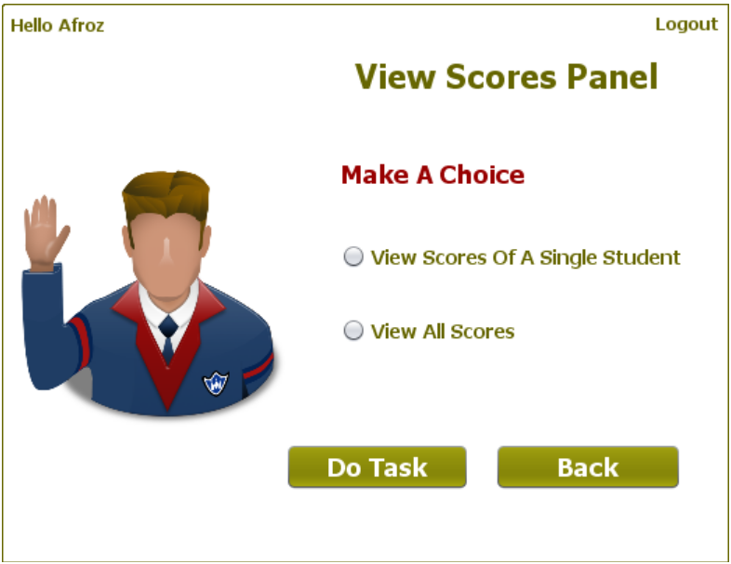

**STEPS TO BE DONE IN** **ViewScoresFrame**

In the **ViewScoresFrame** we need to do following steps:

1. Display **username** on the top left

2. Allow the user to **logout**

3. Write code for the "**Do Task**" Button . When this button is clicked it should:

**a. Validate the inputs. If validation fails it should print the Error Message and return**

**b. If Single Student Score is selected it should open the ViewSingleScoreFrame and if all scores is selected it should open the AllScoresFrame**

**c. Dispose the current frame**

4. Write code for the "**Back**" Button. When this button is clicked it should:

a**. Dispose the current frame and open the AdminOptionsFrame**

**DESIGNING THE validateInputs( ) METHOD:**

**WRITING THE CODE FOR BUTTON Button.png IN ViewScoreFrame**

**WRITING THE CODE FOR BUTTON Button.png IN EditQuestionsFrame**